DBMS PROJECT

Textile store management system

Aashi Nagpal (102216118)

Aarushi Gupta (102216107)

Yash Yadav (102216119)

Aditya Arora(102216036)

INDEX

|  |  |
| --- | --- |
| TOPIC | PAGE NO. |
| Introduction | 1 |
| ER Diagram | 2 |
| ER to Table | 4 |
| Normalization | 5 |
| SQL and PL/SQL | 7 |
| Conclusion | 31 |

INTRODUCTION

This is a mini project on textile store management system, where a complete database consists of the stores(branches), items in each store, customer records, employees present and their respective managers too. In addition, we also have a large number of items with varieties of categories and collections.

Also, we have a mapping of customers buying the respective products and stores with the stock of particular items. We also have the record of how the items come to the store from the suppliers, the mode of travelling and tracking the order with the date.

A couple of triggers, functions, procedures and cursors are implemented in order to make the working of database in a smooth and sophisticated way. Overall, we get to see a miniature of real – time textile store management.

This mini project aims to deliver the real – time essence of textile management, which is prevalent and widely developed by many software enthusiasts all over the world. The relational database is quiet deeply modelled and revealed in a very schematic way. The output of this DBMS is put out in a technical sense to bring out the effectiveness and usefulness of such a model and system.

Though the challenges to build the queries are high, MySQL rather supports all these in a sophistic way with the help of the reserved keywords and clauses provided by them.

ER DIAGRAM

INDIVIDUAL ENTITY RELATIONSHIPS:

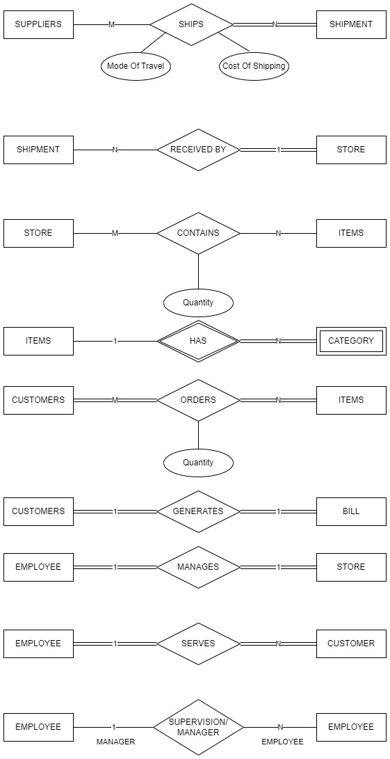

COMPLETE ENTITY RELATIONSHIP DIAGRAM:

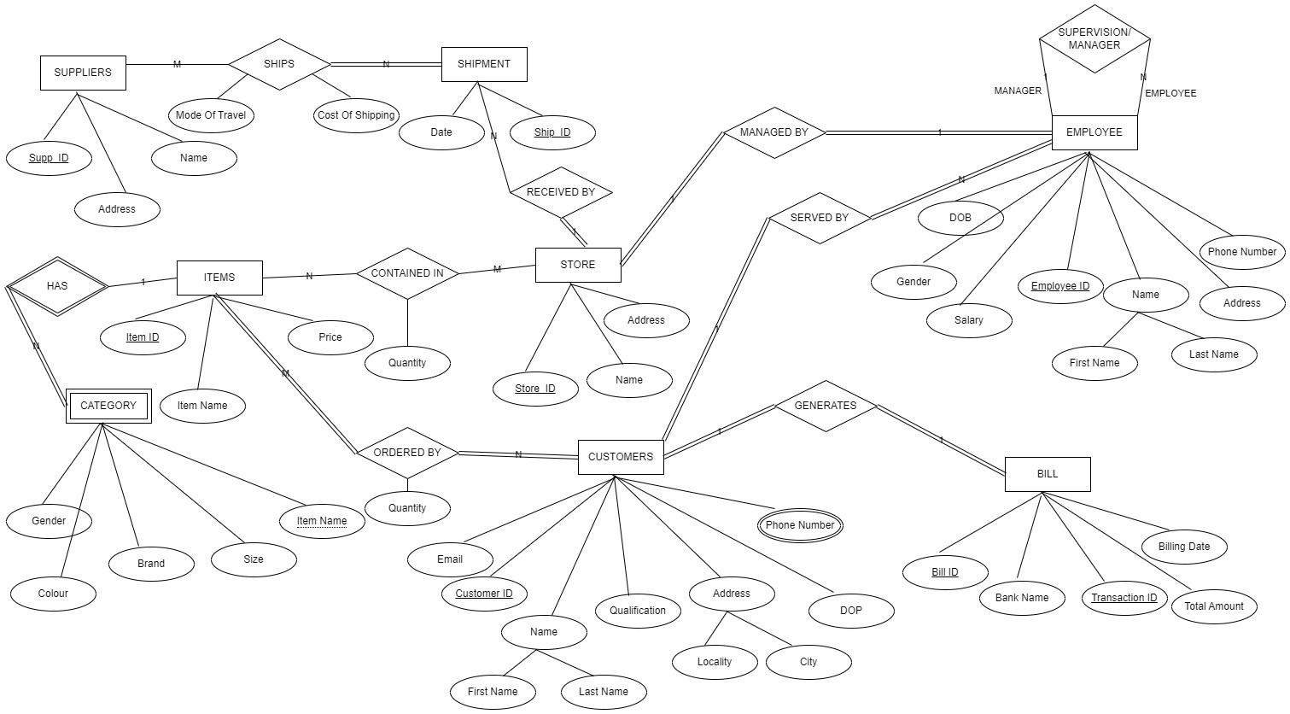

ER TO TABLE

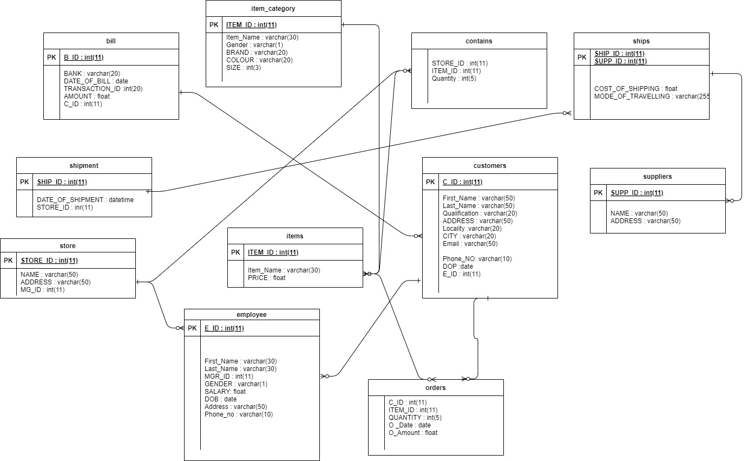

NORMALIZATION

UN-NORMALISED FORM

|  |  |
| --- | --- |
| Table Name | Attributes |
| Customers | C_ID int (11), First_Name varchar (50), Last_Name varchar (50), Qualification varchar (20), ADDRESS varchar (50), Locality varchar (20), CITY varchar (20), Email varchar (50), Phone_NO varchar (10), DOP date, E_ID int (11) |
| Bill | B_ID int (11), BANK varchar (20), DATE_OF_BILL date, TRANSACTION_ID int (20), AMOUNT float, C_ID int (11) |
| Item_category | ITEM_ID int (11), Item_name varchar (30), Gender varchar (1), BRAND varchar (20), COLOUR varchar (20), SIZE int (3) |
| Employee | E_ID int (11), First_Name varchar (30), Last_Name varchar (30), MGR_ID int (11), GENDER varchar (1), SALARY float, DOB date, Address varchar (50), Phone_no varchar (10) |
| store | STORE_ID int (11), NAME varchar (50), ADDRESS varchar (50), MG_ID int (11) |
| Shipment | SHIP_ID int (11), DATE_OF_SHIPMENT datetime, STORE_ID int (11) |
| items | ITEM_ID int (11), Item_Name varchar (30), PRICE float |
| orders | C_ID int (11), ITEM_ID int (11), QUANTITY int (5), O _Date date, O_Amount float |
| suppliers | SUPP_ID int (11), NAME varchar (50), ADDRESS varchar (50) |
| Ships | SHIP_ID int(11), SUPP_ID int(11), COST_OF_SHIPPING float, MODE_OF_TRAVELLING varchar(255) |
| contains | STORE_ID int (11), ITEM_ID int (11), Quantity int (5) |

NORMALISED FORM

|  |  |
| --- | --- |
| Table Name | Attributes |
| Customers | C_ID int (11), First_Name varchar (50), Last_Name varchar (50), Qualification varchar (20), ADDRESS varchar (50), Locality varchar (20), CITY varchar (20), Email varchar (50) |
| Cust_Phone | C_ID int (11), Phone_NO varchar (10) |
| Cust_transac | C_ID int (11), DOP date, E_ID int (11) |
| Bill | B_ID int (11), BANK varchar (20), DATE_OF_BILL date, TRANSACTION_ID int (20), AMOUNT float, C_ID int (11) |
| Item_category | ITEM_ID int (11), Item_name varchar (30), Gender varchar (1), BRAND varchar (20), COLOUR varchar (20), SIZE int (3) |
| Employee | E_ID int (11), First_Name varchar (30), Last_Name varchar (30), MGR_ID int (11), GENDER varchar (1), SALARY float, DOB date, Address varchar (50) |
| Emp_Phone | E_ID int (11), Phone_no varchar (10) |
| store | STORE_ID int (11), NAME varchar (50), ADDRESS varchar (50), MG_ID int (11) |
| Shipment | SHIP_ID int (11), DATE_OF_SHIPMENT datetime, STORE_ID int (11) |
| items | ITEM_ID int (11), Item_Name varchar (30), PRICE float |
| orders | C_ID int (11), ITEM_ID int (11), QUANTITY int (5), O _Date date, O_Amount float |
| suppliers | SUPP_ID int (11), NAME varchar (50), ADDRESS varchar (50) |
| Ships | SHIP_ID int(11), SUPP_ID int(11), COST_OF_SHIPPING float, MODE_OF_TRAVELLING varchar(255) |
| contains | STORE_ID int (11), ITEM_ID int (11), Quantity int (5) |

SQL AND PL/SQL

1) SQL statements for creating tables and inserting data:

Creating table bill:

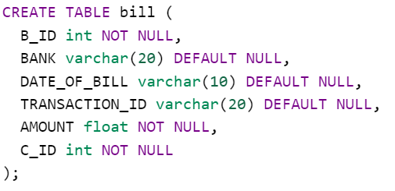

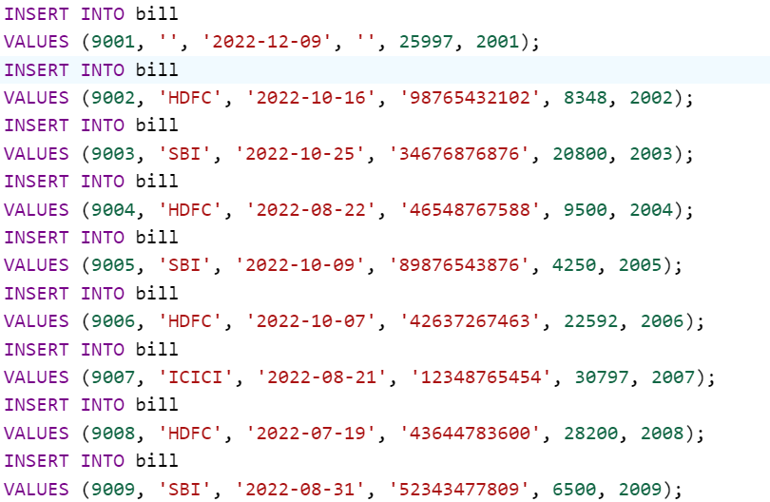

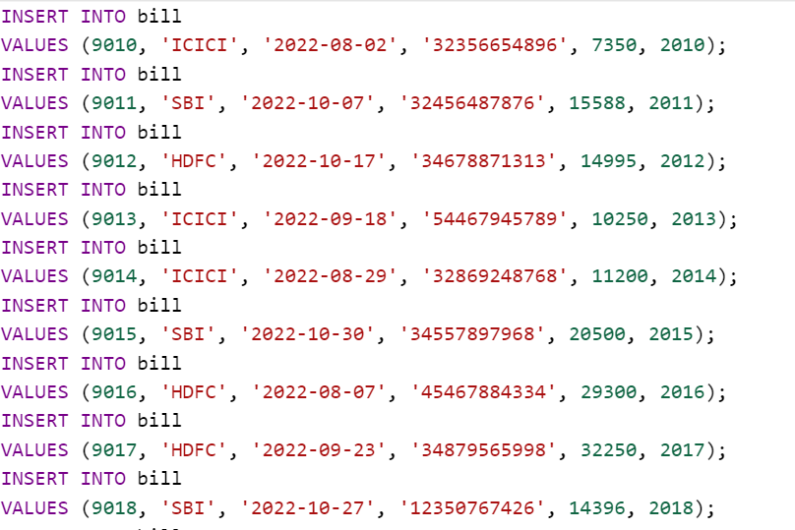

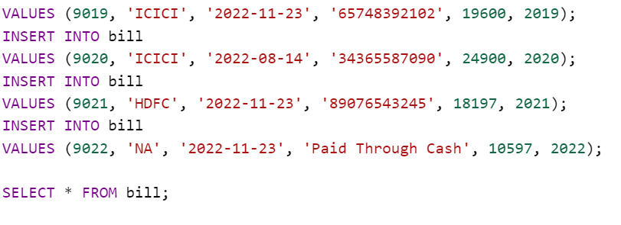

Output:

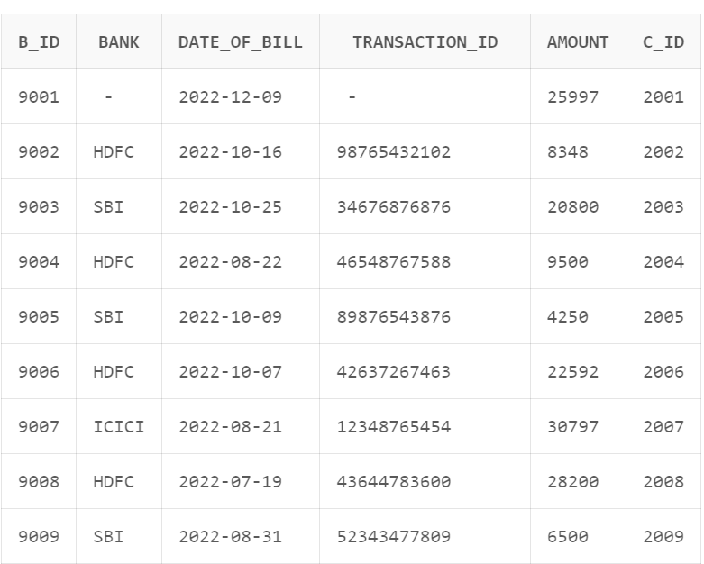

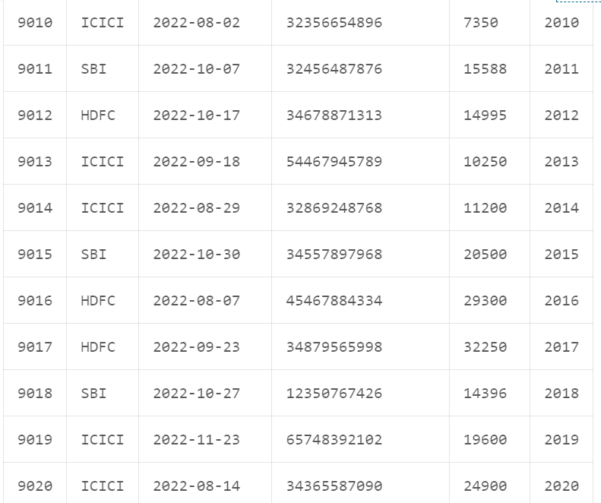

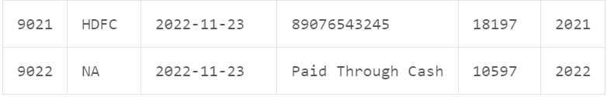

Creating table customers:

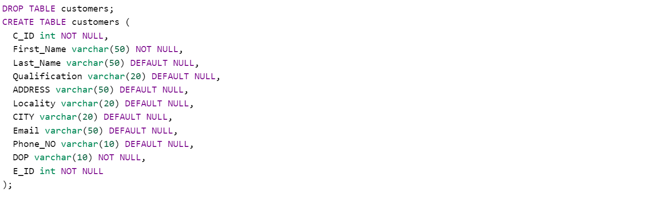

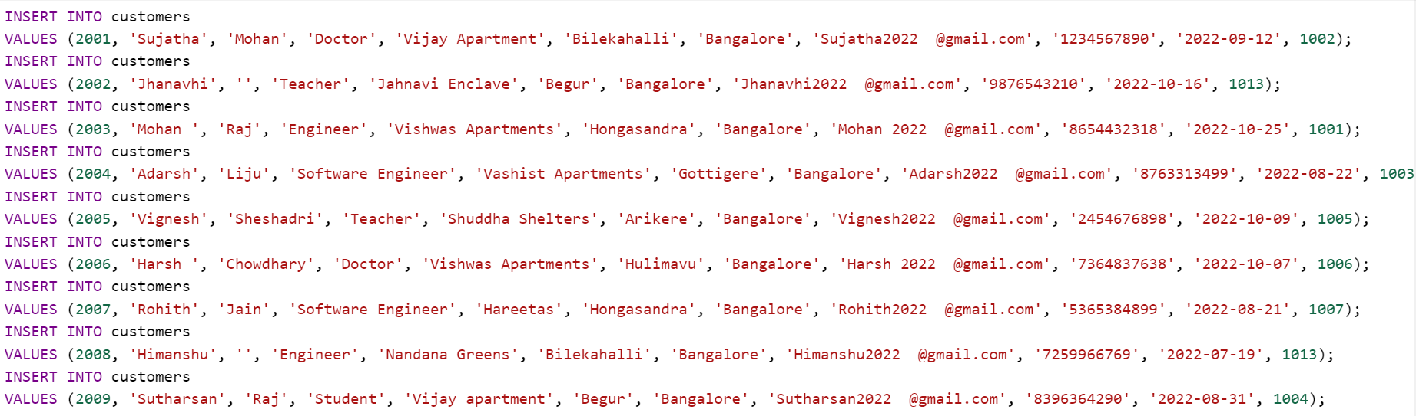

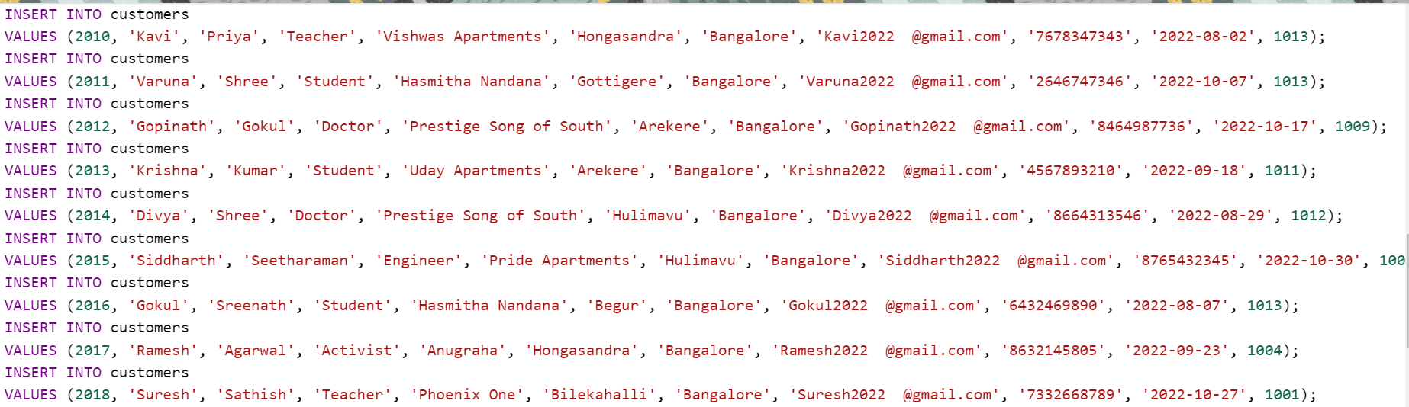

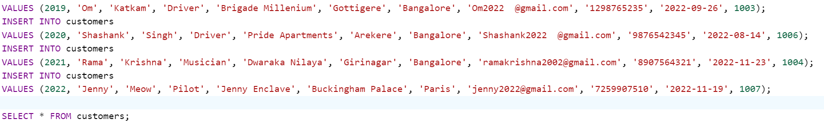

Output:

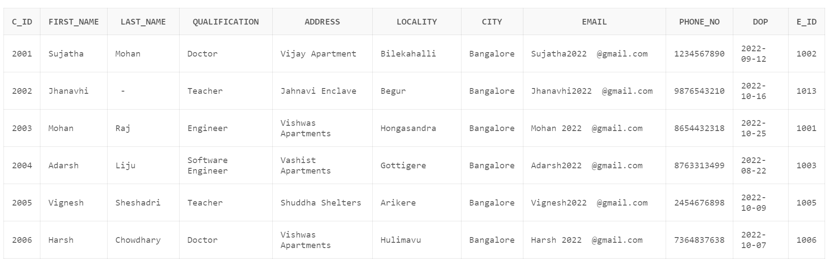

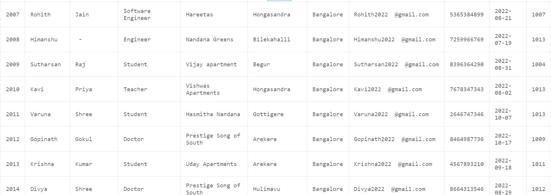

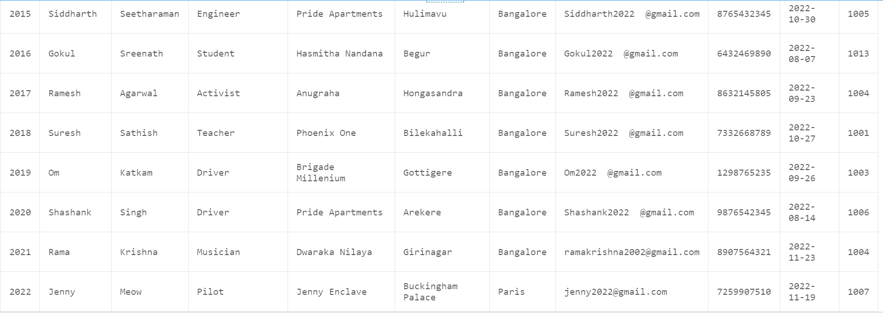

Creating table employee:

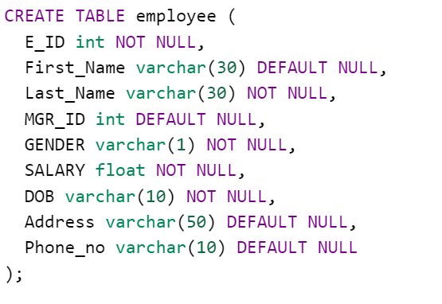

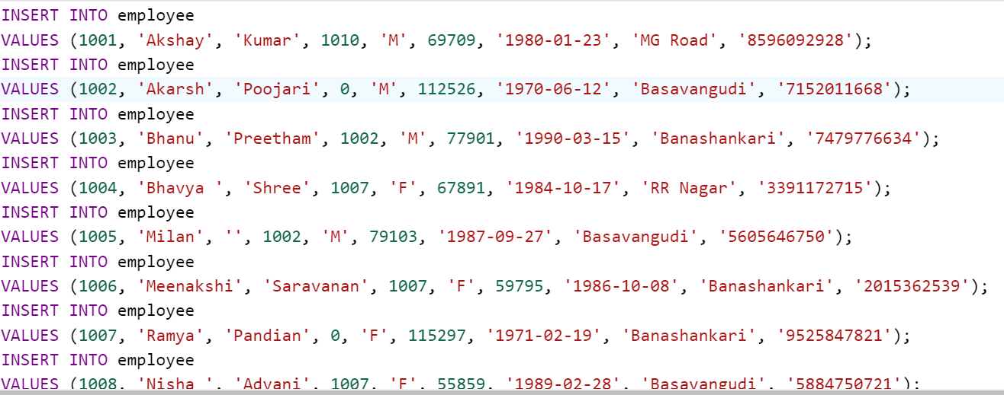

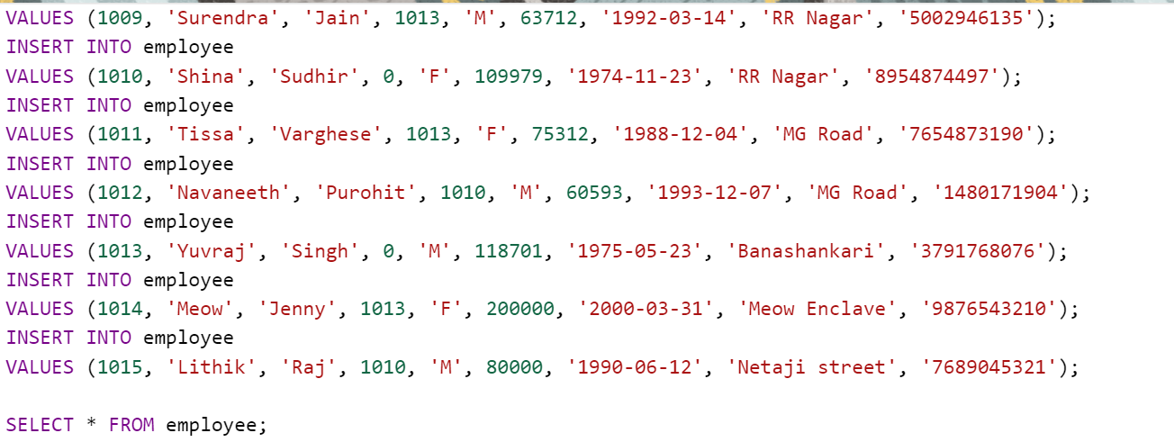

Output:

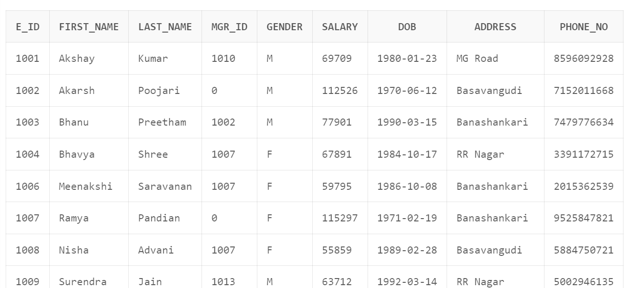

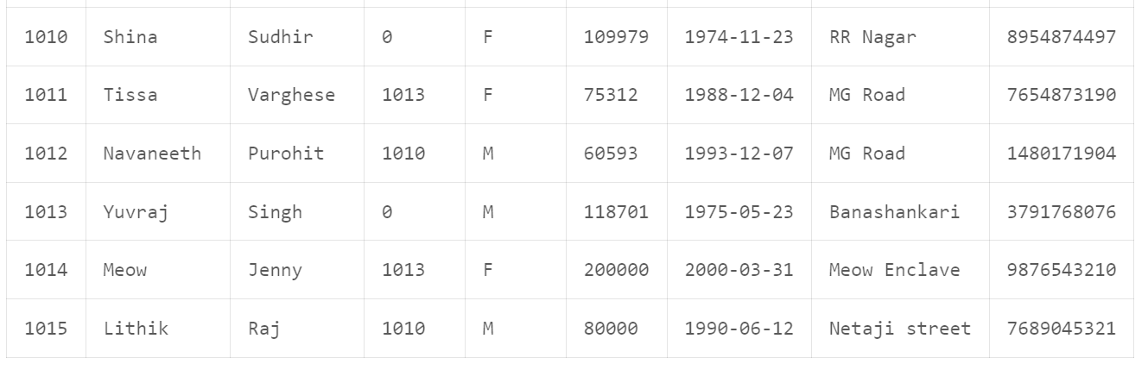

Creating table items:

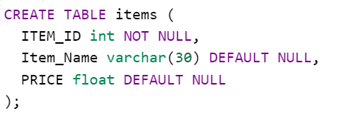

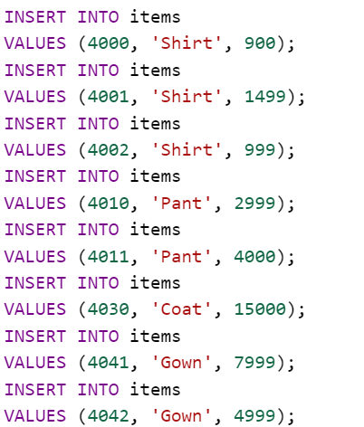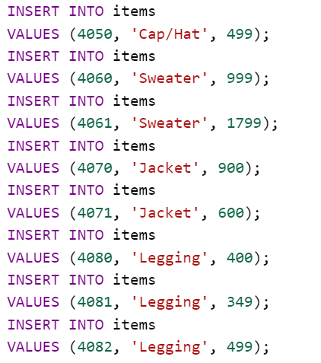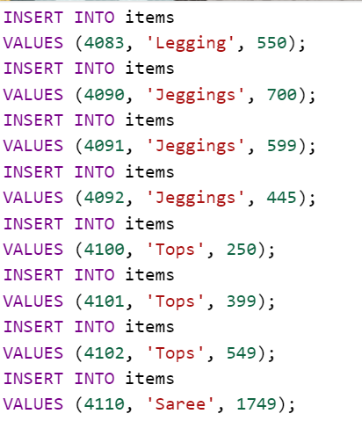

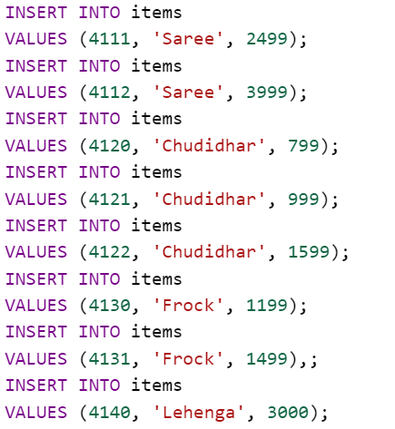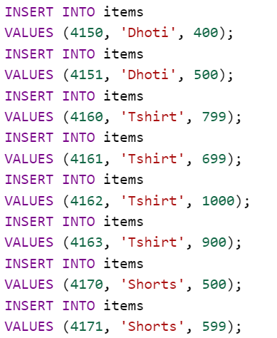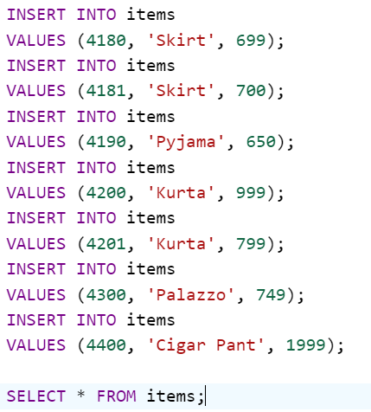

Output:

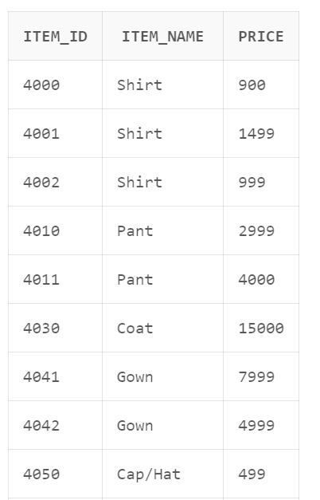 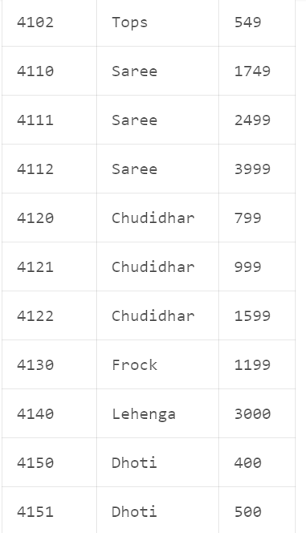

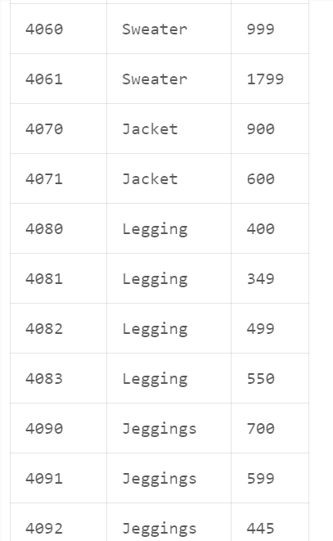 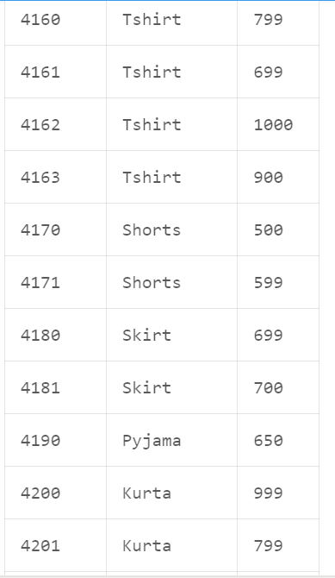

Creating table contains:

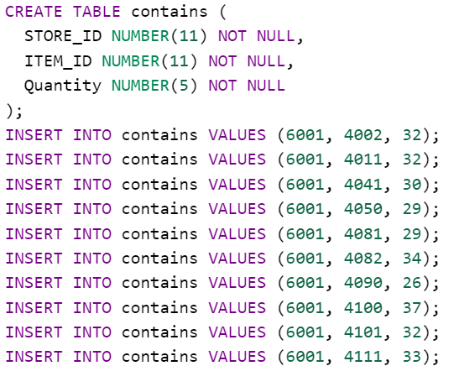

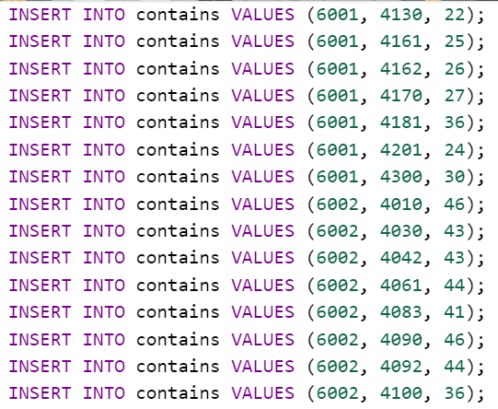

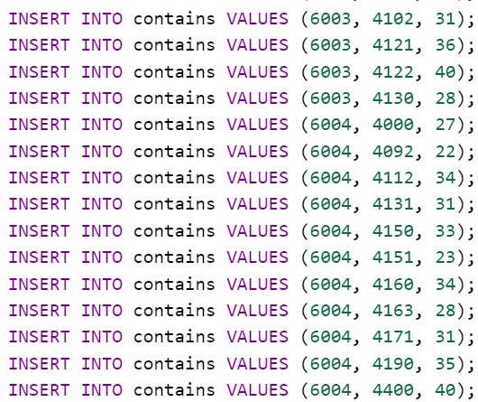

Output:

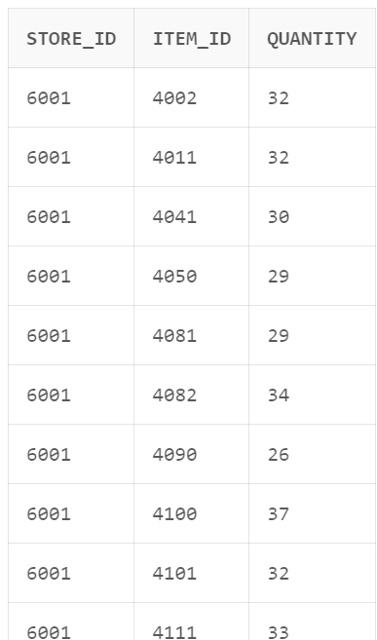 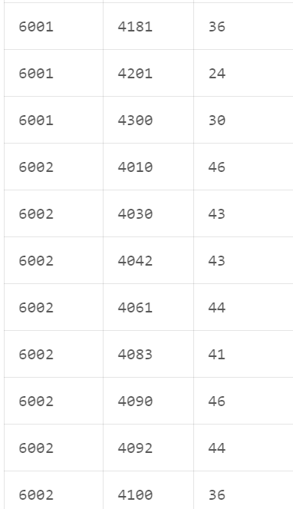

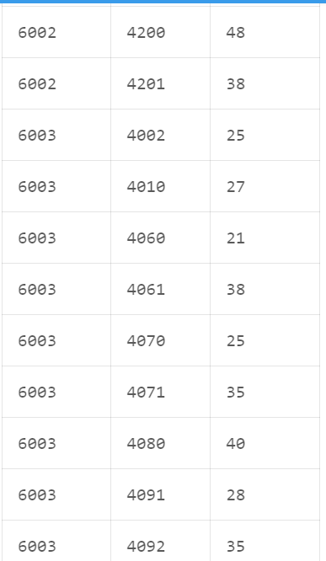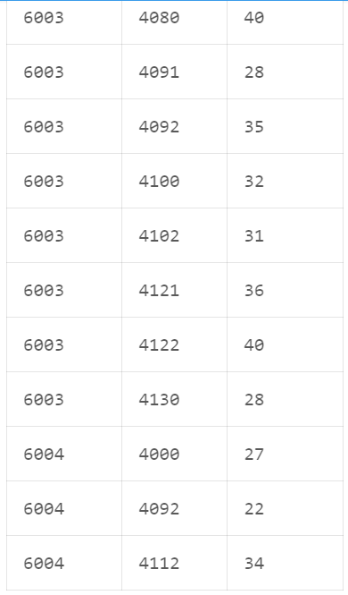

Creating table shipment:

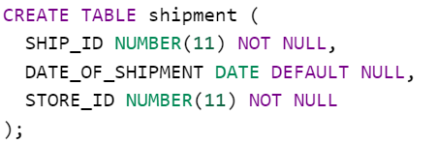

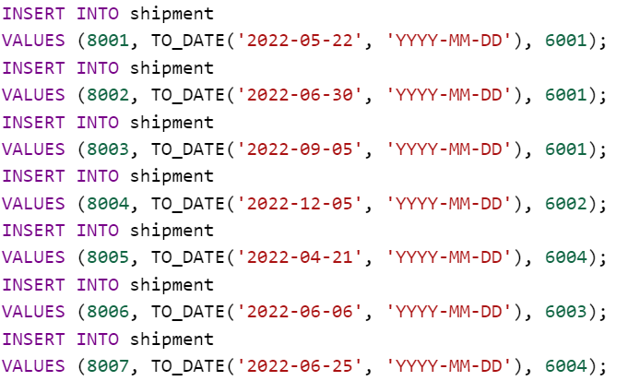

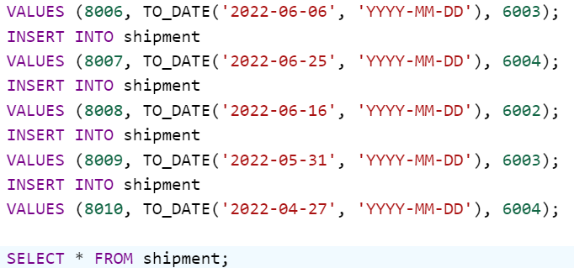

Output:

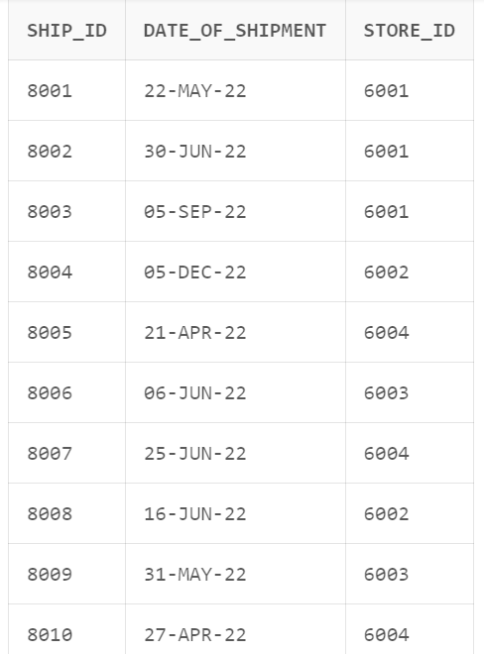

Creating table ships:

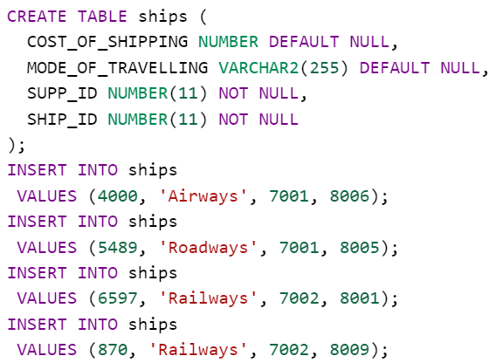

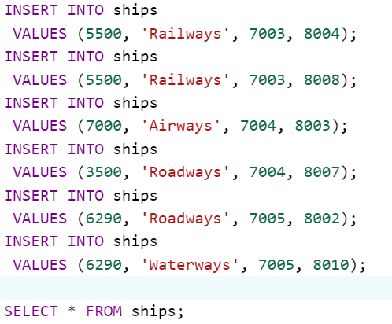

Output:

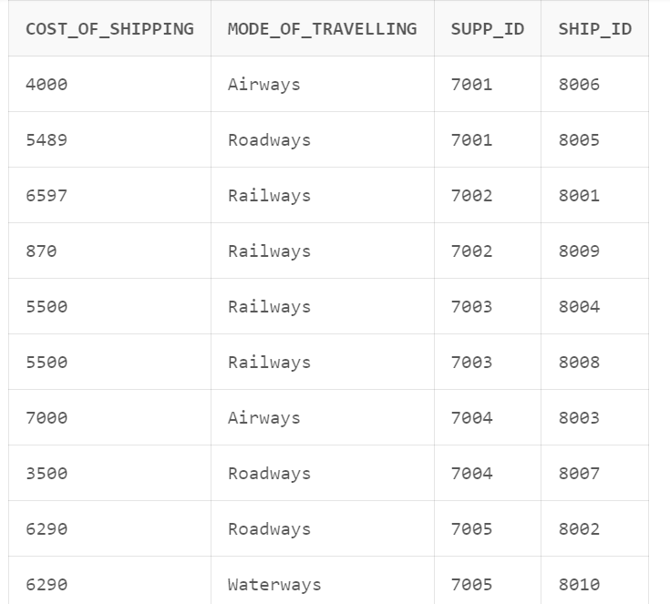

Creating table suppliers:

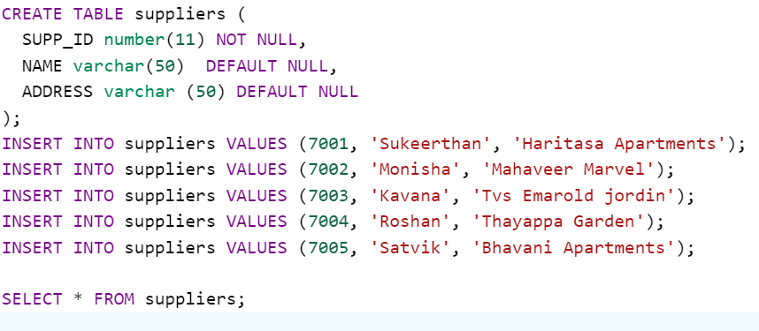

Output:

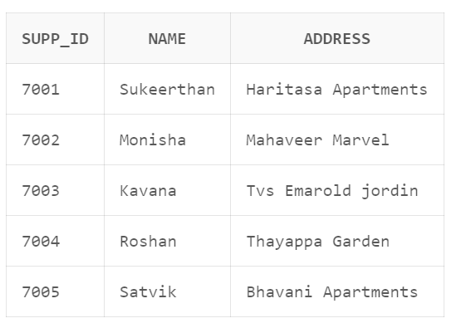

Creating table item_category:

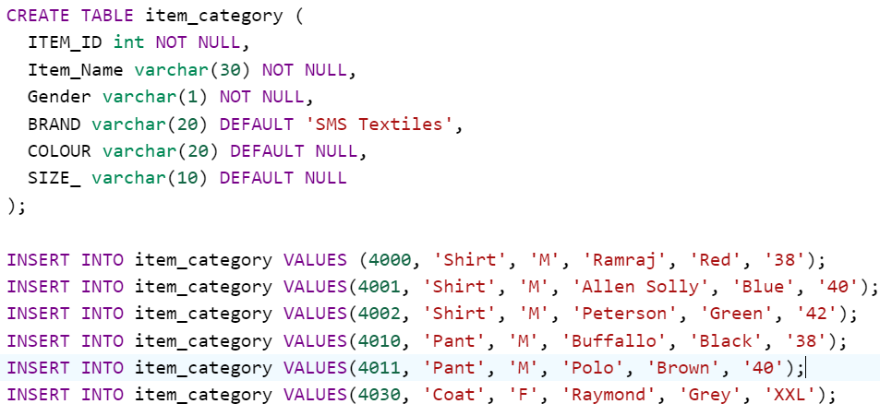

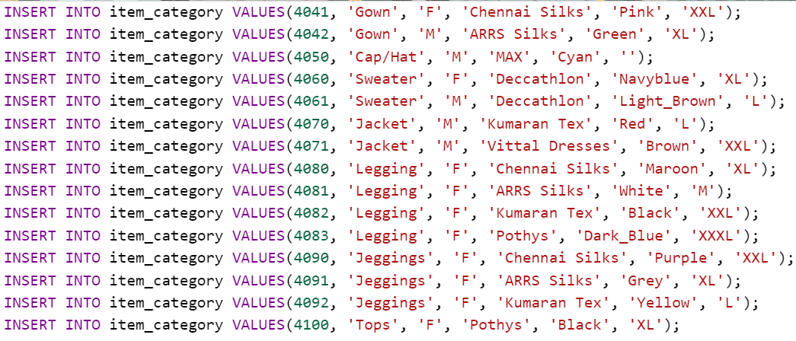

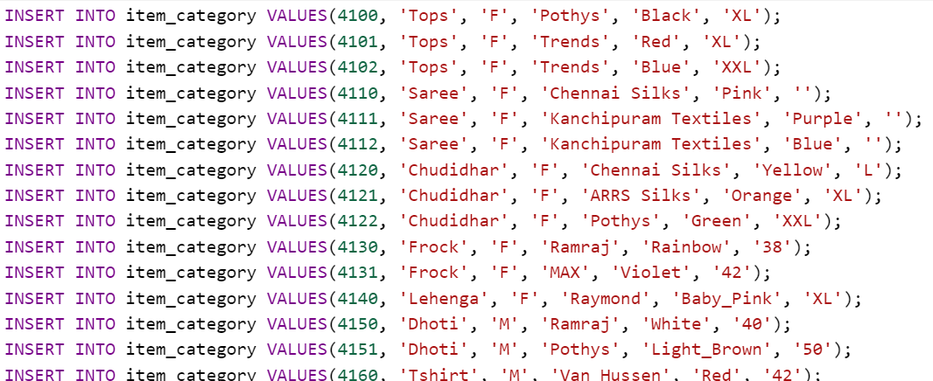

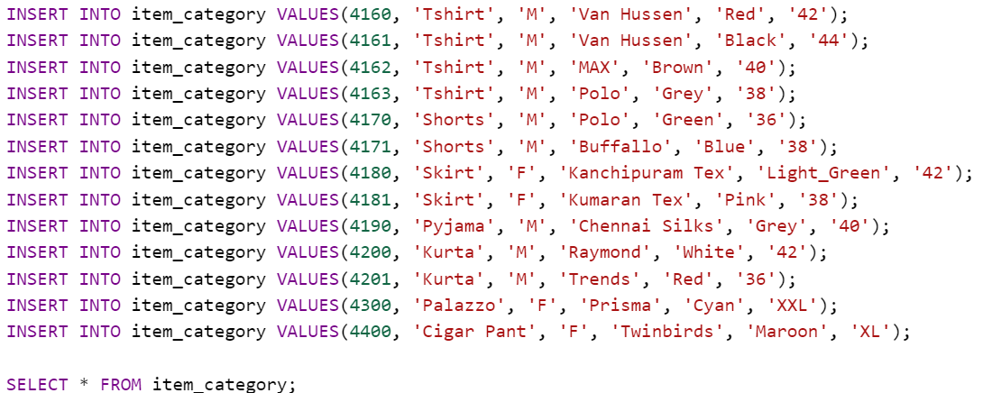

Output:

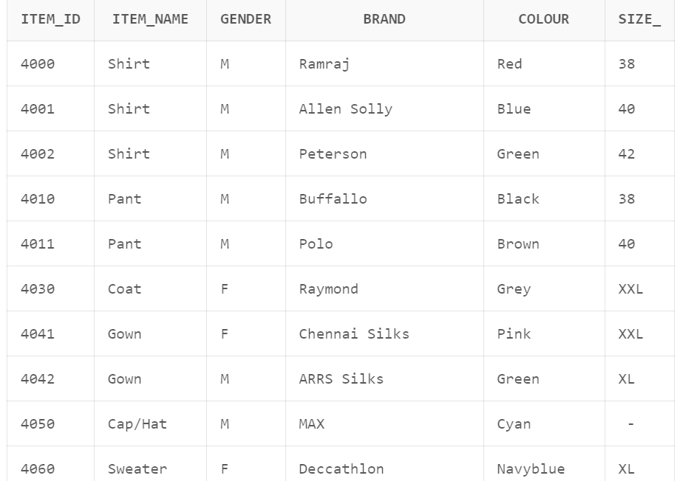

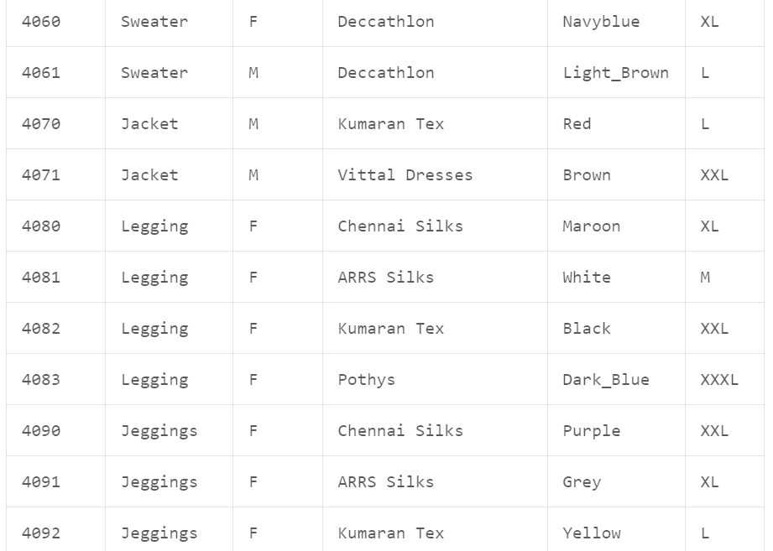

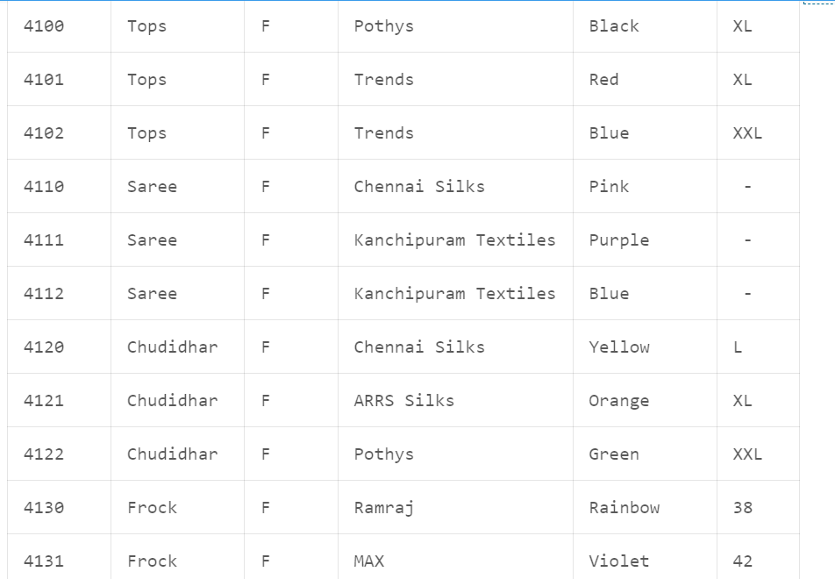

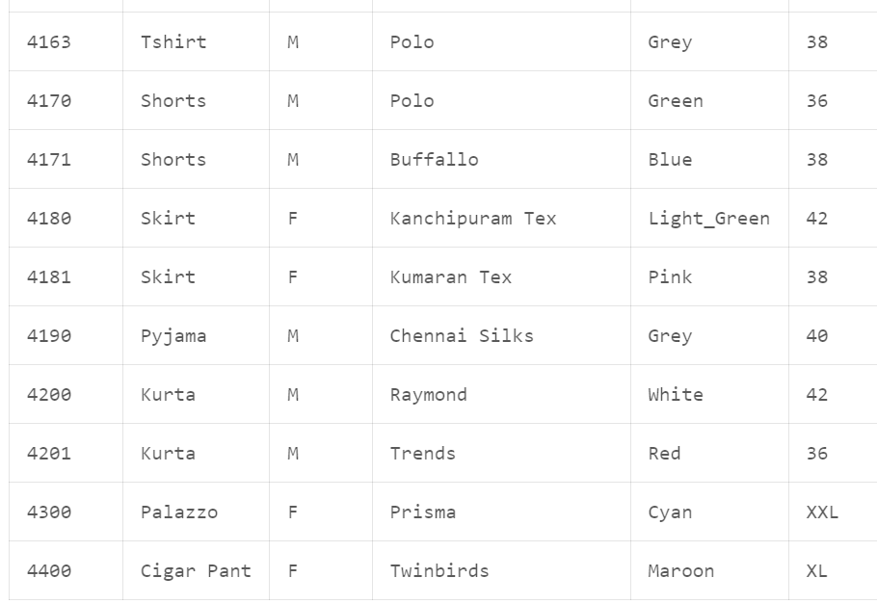

Creating table orders:

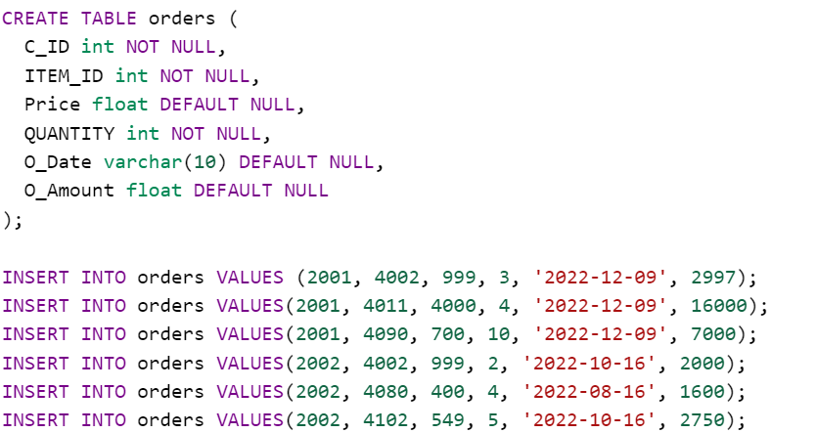

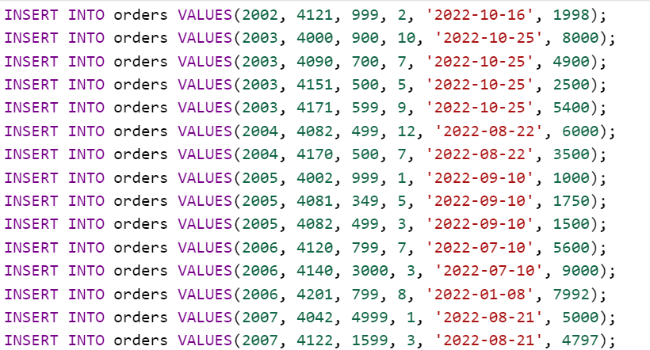

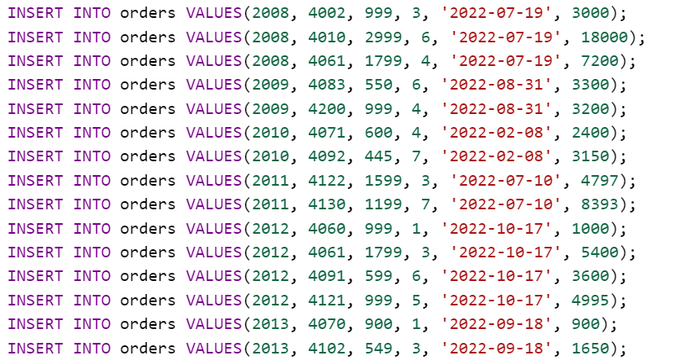

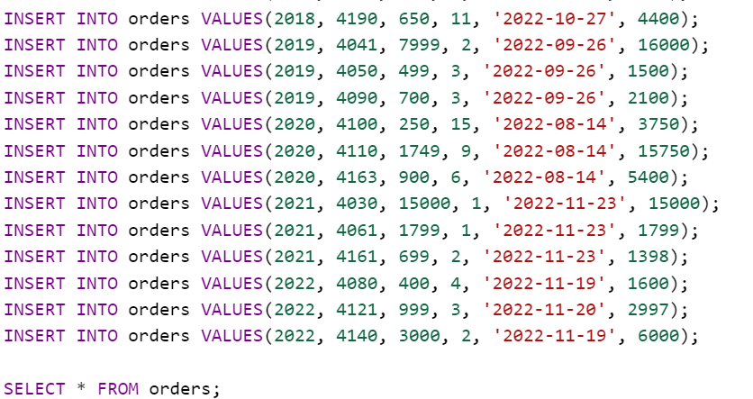

Output:

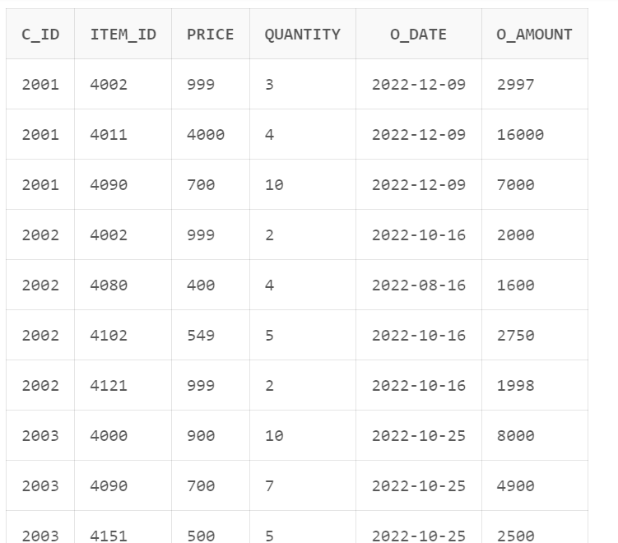

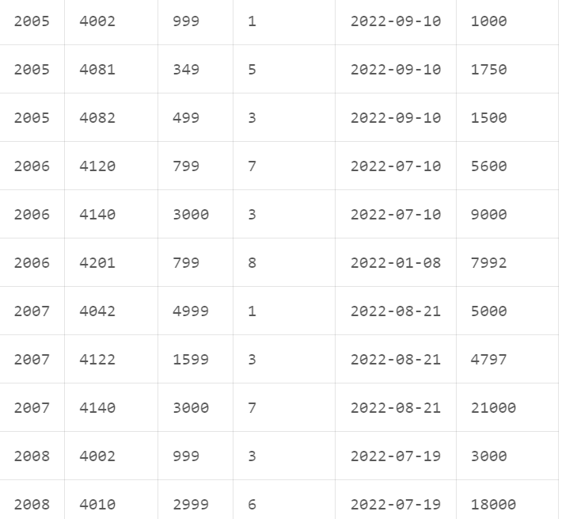

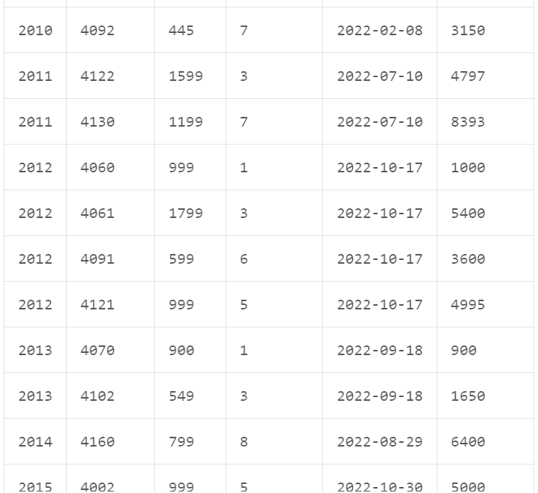

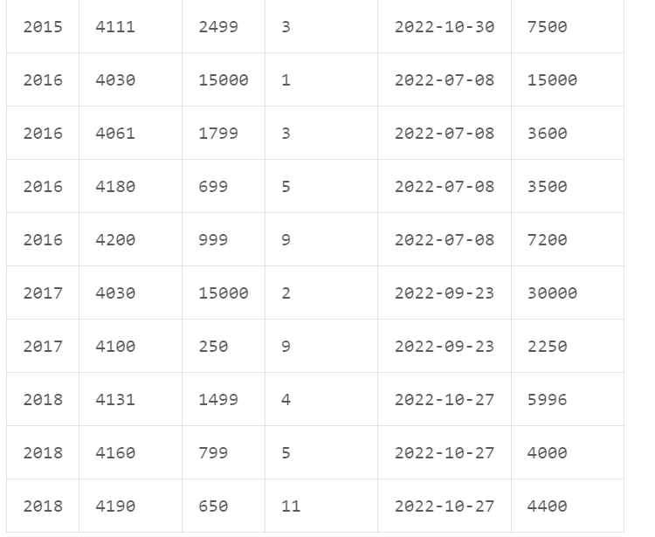

Creating table store:

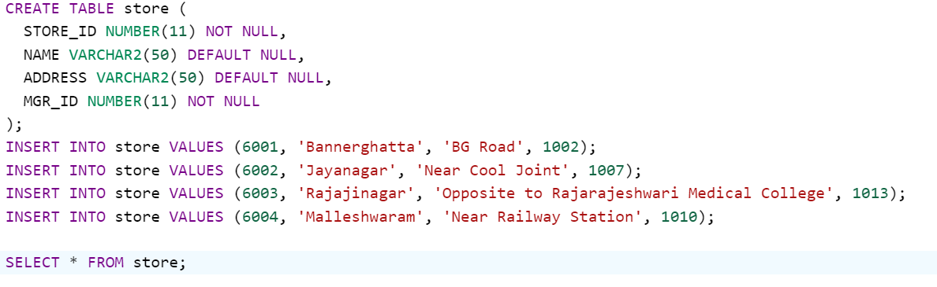

Output:

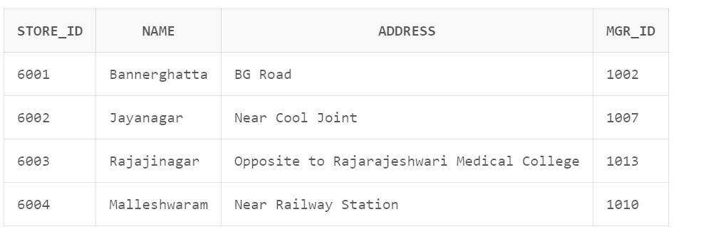

ADDING KEYS AND CONSTRAINTS

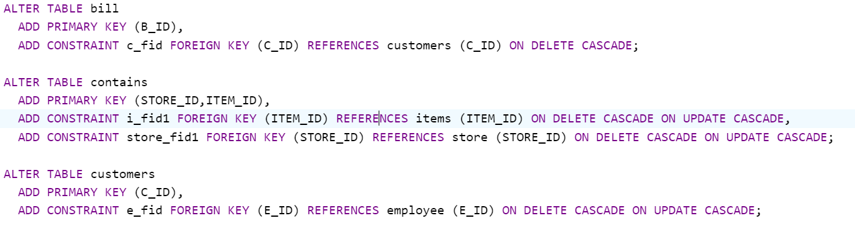

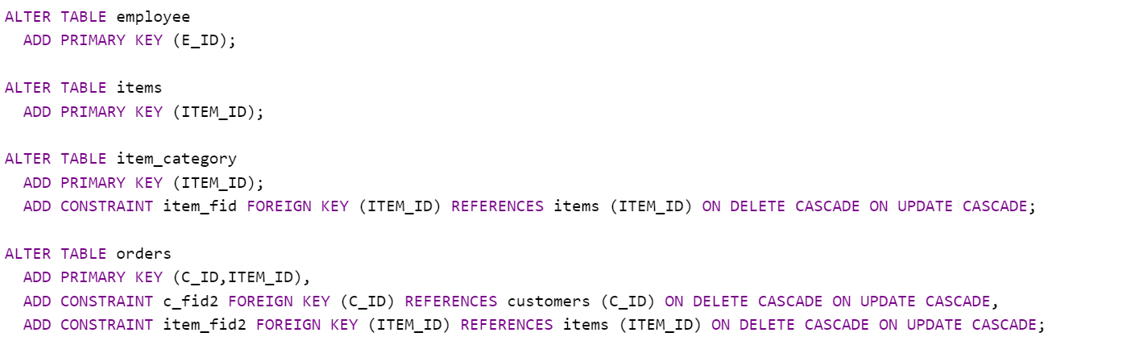

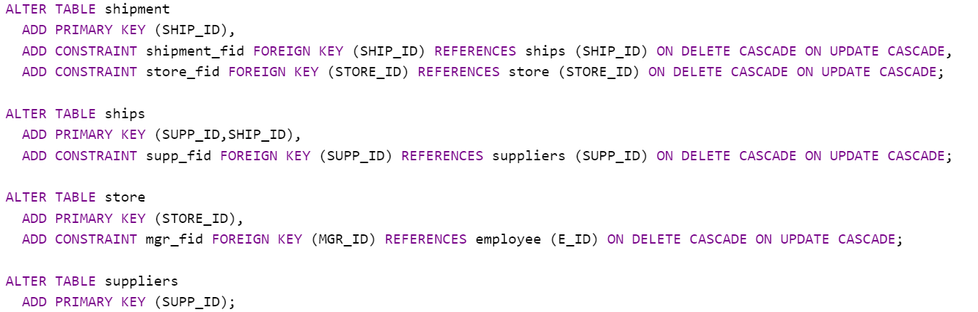

PROCEDURES

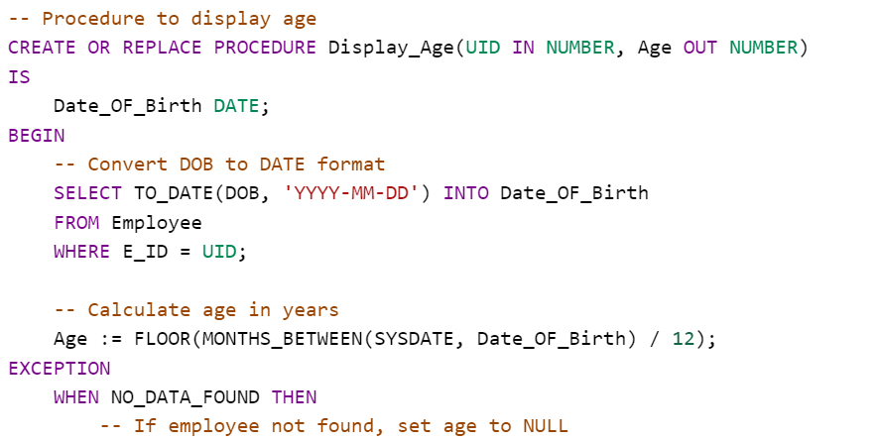

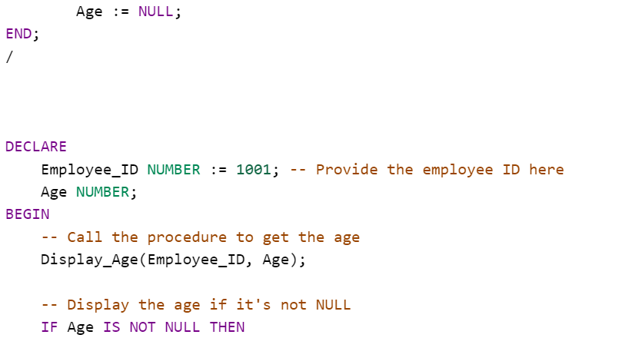

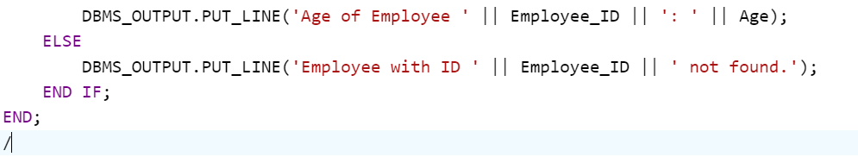

Output:

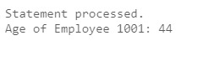

FUNCTIONS

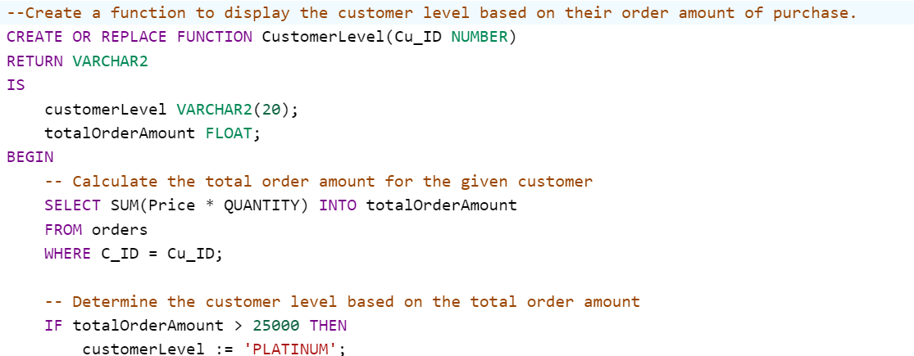

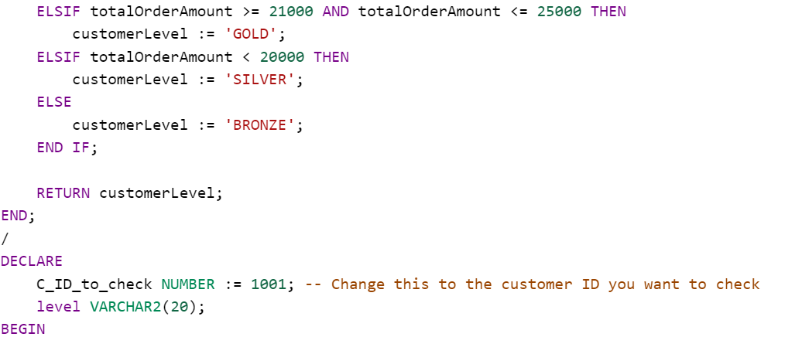

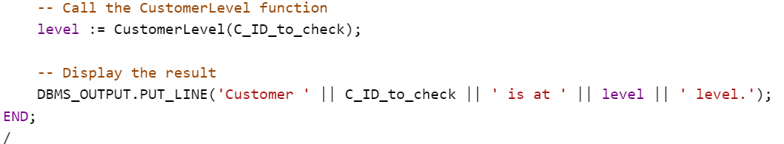

Output:

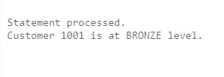

CURSOR

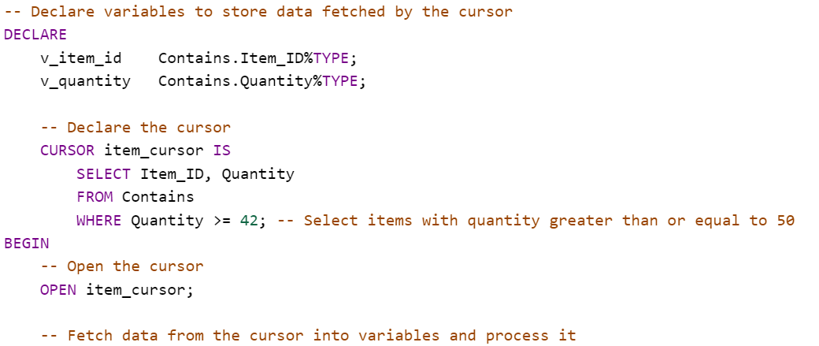

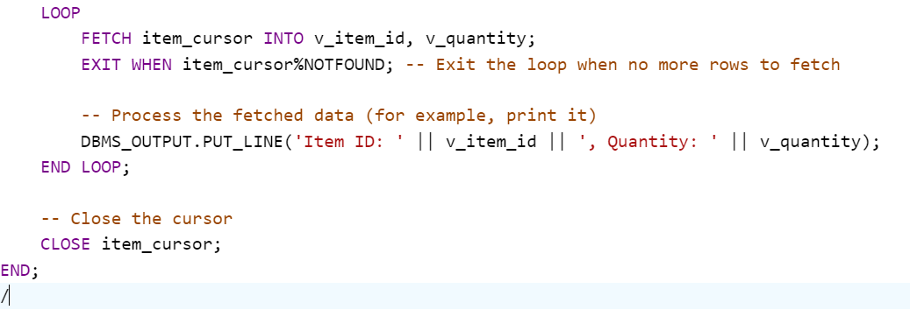

Output:

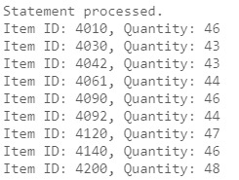

TRIGGER

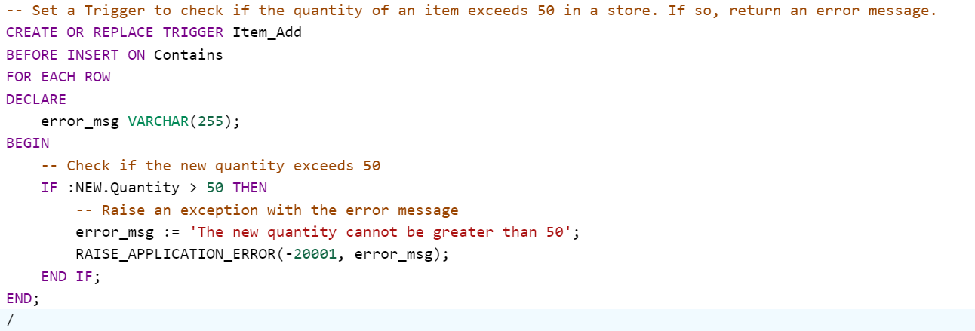

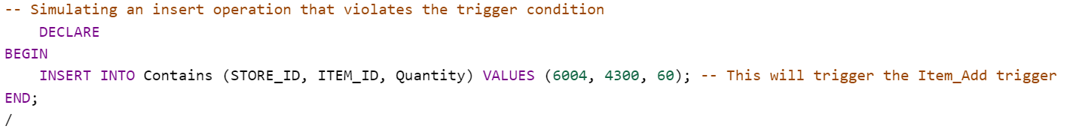

Output:



CONCLUSION

In conclusion, the development of a Textile Store Management System using a Database Management System (DBMS) is a significant step toward enhancing efficiency, accuracy, and customer satisfaction within textile retail operations. By integrating various functionalities, such as product management, inventory control, sales processing, and reporting, the system aims to streamline store operations and improve decision-making.

The Textile Store Management System leverages technology to create a more customer-centric retail experience. By adhering to best practices in database design, security, and usability, the system contributes to the success of textile businesses.